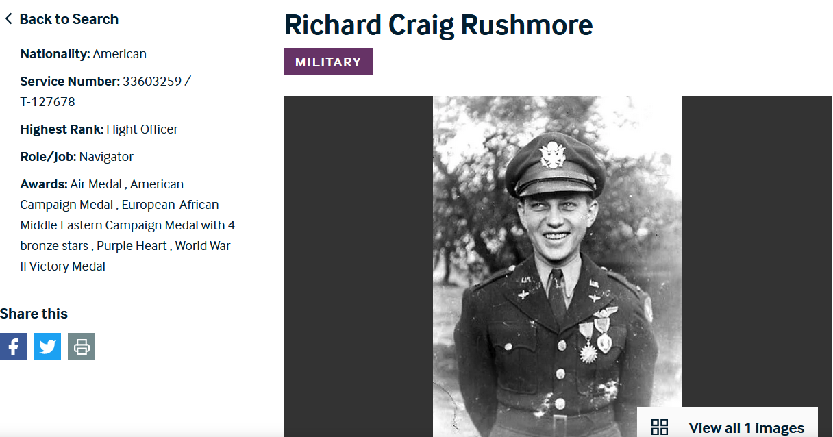
Source: https://www.americanairmuseum.com/archive/person/richard-craig-rushmore

Richard was interviewed by his grandson, Dan Gershey, for the Veterans History Project. The interview was conducted at the kitchen table and is available online at:
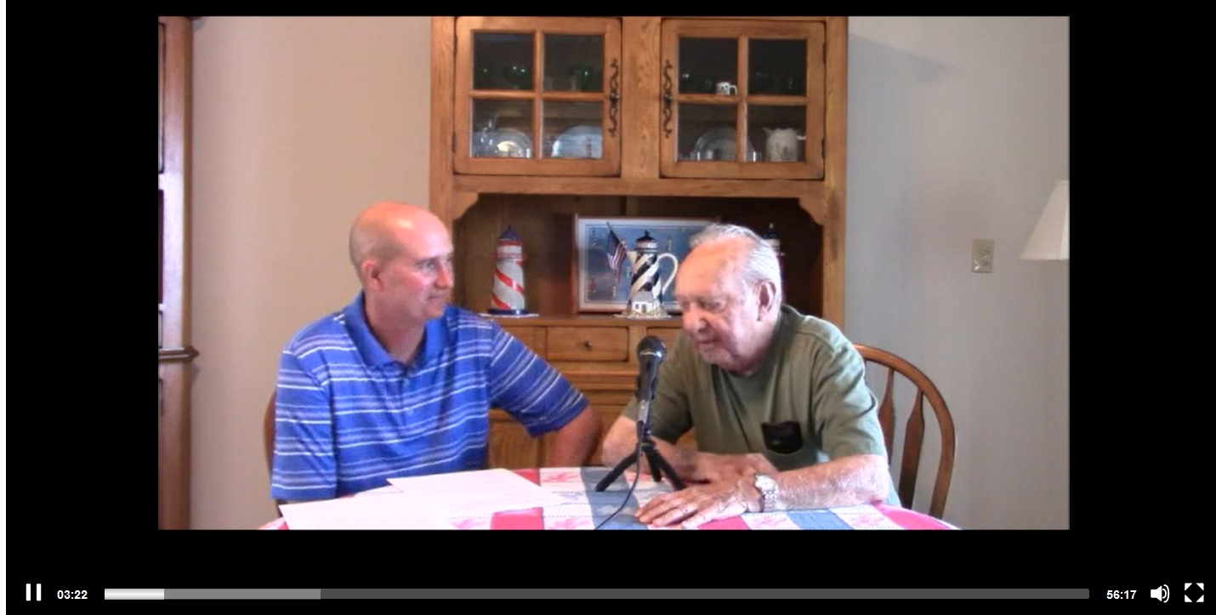
https://www.loc.gov/item/afc2001001.97630/.

Title
- Richard Craig Rushmore Collection

Names
- Gershey, Daniel J.
- Rushmore, Richard Craig

Home State
- Pennsylvania

Headings
- - Rushmore, Richard Craig
- - World War, 1939-1945 -- Personal Narratives
- - United States. Army Air Forces/Corps.
- - Cold War -- Personal Narratives
- - United States. Army.

Form
- DVD

Extent
- 1 item

Repository
- Veterans History Project, American Folklife Center, Library of Congress

Gender
- Male

Race
- White

Status
- veteran

Service History

World War, 1939-1945
  - Branch of Service: Army Air Forces/Corps
  - Unit of Service: 353rd Squadron, 301st Bomb Group, 5th Wing, 15th Air Force
  - Location of Service:
  - Highest Rank: First Lieutenant
  - Dates of Service: 1943-1945
  - Entrance into Service: Commissioned
  - Military Status: veteran
  - Service History Note: The veteran served as a B-17 navigator. He was missing in action in Yugoslavia for 48 days.

Cold War
  - Branch of Service: Army
  - Unit of Service: Army Reserve; 317th Medical Detachment; 338th Medical Group
  - Location of Service:
  - Highest Rank: Colonel
  - Dates of Service: 1961-1962
  - Military Status: veteran

Materials
- Video: DVD [1 item] -- Oral history interview (collected 2014-09-02; 2014)

Collection Number
- AFC/2001/001/97630

Cite as
- Richard Craig Rushmore Collection (AFC/2001/001/97630), Veterans History Project, American Folklife Center, Library of Congress

Online Format
- video

Additional Metadata Formats
- METSXML Record
- METSXML Record

